About Dataset

**Manufacturing process feature selection and categorization**

Content

Abstract: Data from a manufacturing process

Data Set Characteristics: Multivariate

Number of Instances: more than 1500

Area: Medical/electronics

Attribute Characteristics: Real

Number of Attributes: more than 550

Associated Tasks: Classification, Causal-Discovery

A complex modern Ultrasound manufacturing, assembly and testing process is normally under consistent surveillance via the monitoring of signals/variables collected from sensors and or

process measurement points.

Almost all of these signals are equally valuable in a specific monitoring, Assembly & testing system.

The measured signals contain a combination of useful information, irrelevant information as well as noise. It is often the case that useful information is buried in the latter two.

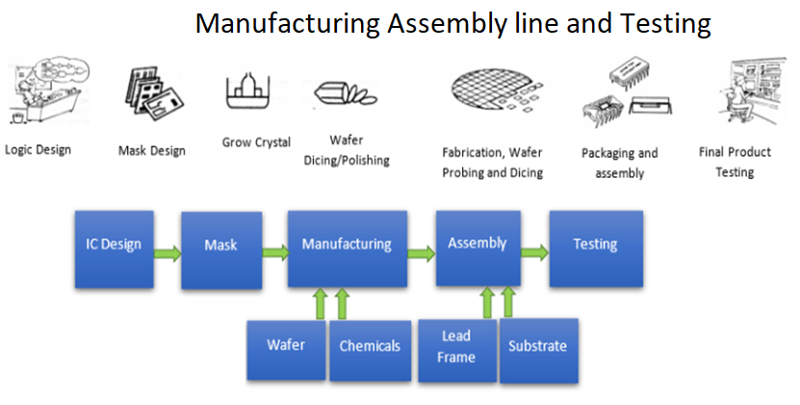

A large number of vendors, suppliers are involving in the manufacturing and assembly of the devices.

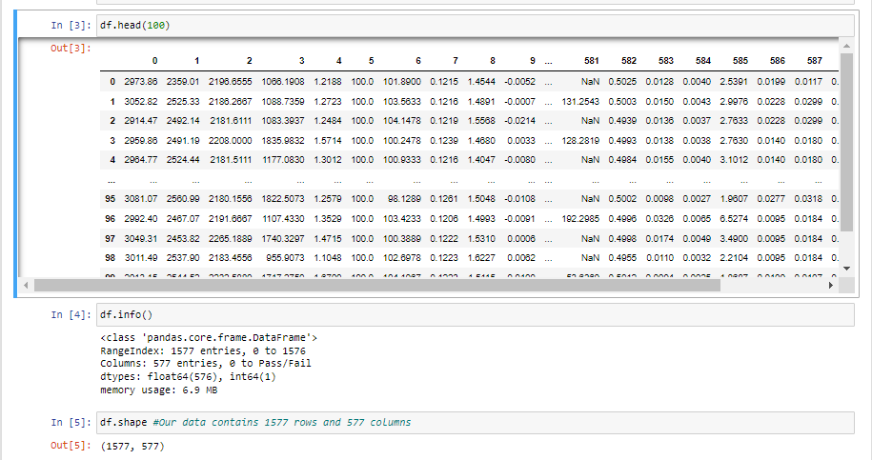

**objective:**

* To save the manufacturing time and cost, Reduce the number of testing points (currently it is more than 550, Target to reduce it at-least 140.)

Important: - After reduction of Testing points 550 to 140, the assembly line will be redesign to save money without significant compromise in quality.